1a)

1. M,N ::= x | λx.M | MN
2. A,B ::= phi | (A -> B)
3. (Ax) Gamma, x:A |- x:A (with a line on top)  
   (-> I)

b)



c)

_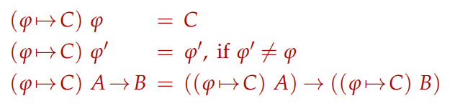

Soundness : (Lemma 2.11 page 18)

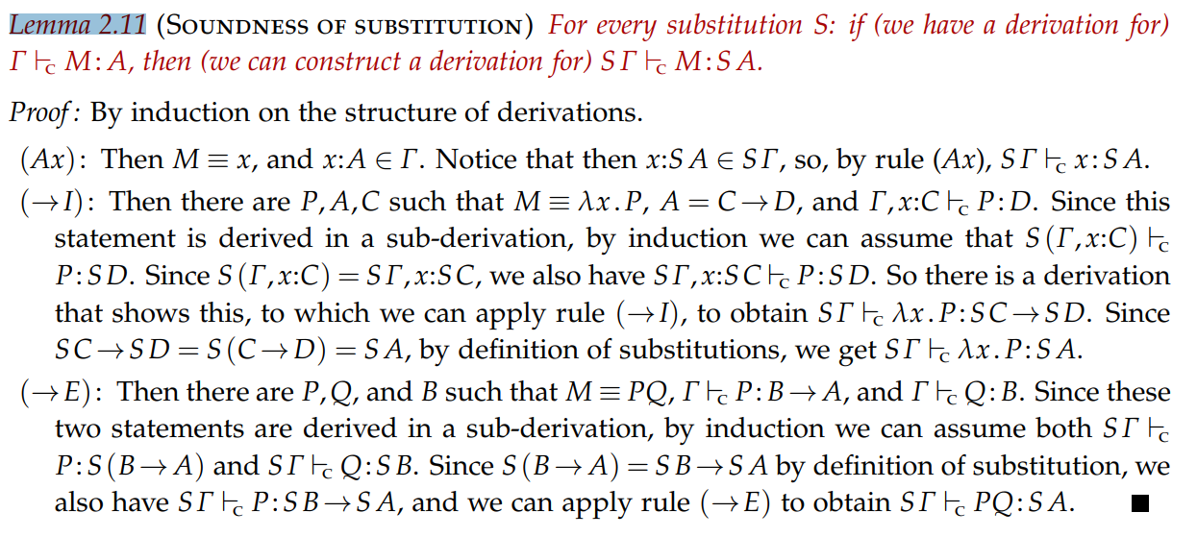

d)

Not sure what syntax to add??

For rules, forall introduction /elimination need to be added. Unsure about other rules

2.

1. (This is exercise 7.21)

**Rewrite rules:**

Fac 0 -> Succ 0

Fac (Succ n) -> Times (Succ n) (Facl n) (The one in the notes is wrong we believe)

Model answer says: Fac (Succ n) -> Times n (Fac n)  
This would give factorial 5 = 4 * factorial 4 (This is not right)

Environment:

Times : Int -> Int -> Int

Succ: Int -> Int

Cons : Int -> IntList -> IntList

Fac: Int -> Int

Derivation: (Show that LHS and RHS of rules match)

Fac: Int -> Int 0: Int

--------------------------  
Fac 0 : Int

Succ: Int -> Int 0: Int

----------------------------

Succ 0 : Int

Fac (Succ n) : Int

Times (Succ n) (Fac n) : Int   
Left as exercise to the reader

1. We add the rule:

Facs n -> Cons (Fac n) (Facs (Succ n))  
  
Our term (program) will be Facs 0

Give environment:  
Facs -> Int -> IntList

Derive Fac n -> Int

Derive Cons (Fac n) -> IntList -> IntList

Derive Facs (Succ n) -> IntList

Therefore final derivation of Facs n is IntList

c)

ML Expression for Factorial:

Factorial = fix f.lambda n if (isZero n) then (Succ 0) else (Times n (f (MinusOne n)))

d)

ML expression for factorial lists:

Facs = fix f. Lambda n. Cons (Fac n) (f (Succ n))

List = Facs 0

3a)

Terms:

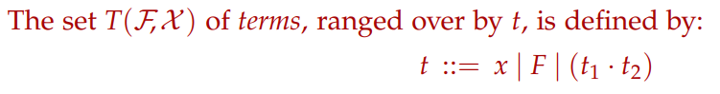

A term is either a variable, a function symbol or an application of t

Rewrite Rules:

Reduction: (Definition 7.2)  
Not sure how to word this, but based on the above, you can replace any *redex* l^R with its *contractum* r^R inside a context C, this is a reduction?

Curry type assignment for TRS: Definition 7.8

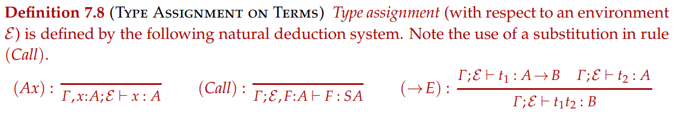

b)

B : (2 -> 3) -> (1 -> 2) -> 1 -> 3

C: (2 -> 1 -> 3) -> 1 -> 2 -> 3

K: 1 -> 2 -> 1

S -> (1 -> 2 -> 3) -> (1 -> 2) -> 1 -> 3

You now, the standard stuff. REMEMBER THIS

c) This is in the CW, cba to do it here (Exercise 7.18)

Give PP or left hand of rule, then derive both left and right

d) You would have to change the environment of S to (1 -> 1 -> 3) -> (1 -> 1) -> 1 -> 3

4)

1. A) Definition 9.1

B) Definition 9.3

1. A) Example 9.1 in the notes

B) Exercise 9.16 in answers

C) Example 9.5 in notes

Piece of advice, don’t do Q4 in these papers